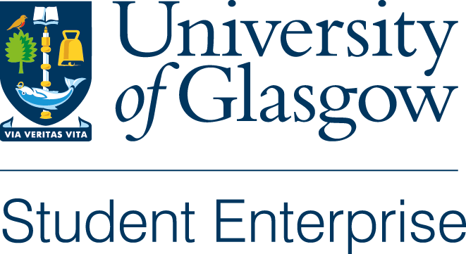

Santander Summer Company

Programme 2023

Application Form

Thank you for your interest in applying for the Santander Summer Company Programme. Please note that **applications close** **at 17.00 on Friday 5th May 2023**. Late entries will not be accepted.

Please return your completed application to [studententerprise@glasgow.ac.uk](mailto:studententerprise@glasgow.ac.uk)

Lead Applicant’s Name:

Address:

City:

Postcode:

Email address:

Mobile No:

Course and year of study:

Names of co-applicants if applicable:

1. Brief description of your business proposition (max 300 words):
2. Potential Markets / Market Analysis:
3. Competition and Competitive Advantage:
4. Potential Customers and their needs:
5. Your Team:
6. Financial Projections:
7. Why do you want to take part in the Summer Company Programme?
8. What would you use the £2.5K funding for?
9. What do you think you need to do to take your business idea to the next level?
10. Would you make use of the mentorship opportunities and incubation space available in the ARC on a regular basis during the summer?

Please include any additional information that you think may be relevant in the evaluation of your business idea.

Those applicants shortlisted will be notified on Tuesday 9th May and will be asked to present their business idea to our external selection panel w/b 15th May (date to be agreed). Presentations should last no longer than 10 minutes and will be followed by a Q&A session.

A total of 4 businesses will be selected to take part in the programme and will be offered incubation space in the Enterprise Suite in the Advanced Research Centre, alongside our current start-ups. Each business will also receive £2500 in funding, access to the Summer Workshop Programme and additional bespoke workshops and 1-2-1 mentorship support.

The programme will run from 1st -31st August 2022.